A PROJECT REPORT

Submitted by

Shahnoor Ahmed Laskar (24BDA70281)
Prasun Shukla (24BDA70265)

in partial fulfillment for the award of the degree of

BACHELOR OF ENGINEERING

IN

COMPUTER SCIENCE AND ENGINEERING
WITH SPECIALIZATION IN DATA SCIENCE


Chandigarh University

Apr 2026


BONAFIDE CERTIFICATE

Certified that this project report “PARKEASE-AN URBAN SMART PARKING PLATFORM” is the bonafide work of “SHAHNOOR AHMED LASKAR, PRASUN SHUKLA” who carried out the project work under my/our supervision.

SIGNATURE

Dr. Aman Kaushik

HEAD OF THE DEPARTMENT

AIT-CSE (Core)

SIGNATURE

Sheth Heet Dhavalbhai

SUPERVISOR
Instructor, Full Stack

AIT-CSE (Core)

Submitted for the project viva-voce examination held on

INTERNAL EXAMINER EXTERNAL EXAMINER

TABLE OF CONTENTS

List of Figures 7
List of Tables 8
List of Standards 9
CHAPTER 1. INTRODUCTION 11
  - Identification of Client/ Need/ Relevant Contemporary issue 11
  - Identification of Problem 11
  - Identification of Tasks 11
  - Timeline 11
  - Organization of the Report 11
CHAPTER 2. LITERATURE REVIEW/BACKGROUND STUDY 12
  - Timeline of the reported problem 12
  - Existing solutions 12
  - Bibliometric analysis 12
  - Review Summary 12
  - Problem Definition 12
  - Goals/Objectives 12
CHAPTER 3. DESIGN FLOW/PROCESS 13
  - Evaluation & Selection of Specifications/Features 13
  - Design Constraints 13
  - Analysis of Features and finalization subject to constraints 13
  - Design Flow 13
  - Design selection 13
  - Implementation plan/methodology 13
CHAPTER 4. RESULTS ANALYSIS AND VALIDATION 14
4.1. Implementation of solution 14
CHAPTER 5. CONCLUSION AND FUTURE WORK 15
  - Conclusion 15
  - Future work 15
REFERENCES 16
APPENDIX 17
- Plagiarism Report 17
- Design Checklist 17
USER MANUAL 18

Figure 1.1 ………………………………………………………………………………….2
Figure 2.1 ………………………………………………………………………………….5
Figure 2.2 …………………………………………………………………………….……7
Figure 2.3 ………………………………………………………………………………….8
Figure 3.1 ………………………………………………………………………………….13
Figure 3.2 …………………………………………………………………………….……14
Figure 3.3 ………………………………………………………………………………….14
Figure 3.4 ………………………………………………………………………………….15
Figure 3.5 …………………………………………………………………………….……16
Figure 3.6 ………………………………………………………………………………….16
Figure 3.7 ………………………………………………………………………………….17
Figure 4.1 …………………………………………………………………………….……18
Figure 4.2 …………………………………………………………………………….……19
Figure 4.3 …………………………………………………………………………….……19
Figure 4.4 …………………………………………………………………………….……20
Figure 4.5 …………………………………………………………………………….……21
Figure 4.6 …………………………………………………………………………….…… 22
Figure 4.7 …………………………………………………………………………….……22
Figure 4.8 …………………………………………………………………………….……23

Table 1.1 ………………………………………………………………………………….3
Table 2.1 ………………………………………………………………………………….6
Table 2.2 …………………………………………………………………………….……8
Table 3.1 …………………………………………………………………………….……10
Table 3.2 …………………………………………………………………………….……11
Table 3.3 …………………………………………………………………………….……12
Table 3.4 …………………………………………………………………………….……14
Table 4.1 …………………………………………………………………………….……18
Table 4.2 …………………………………………………………………………….……20
Table 4.3 …………………………………………………………………………….……23
Table 5.1 …………………………………………………………………………….……25

Standard | Publishing  Agency | About the standard | Page no
REST (Representational State Transfer) | Roy Fielding / IETF | REST is an architectural style for distributed hypermedia systems defining constraints for stateless, client-server, uniform-interface web services. ParkEase backend API follows REST principles across all 7 endpoints. | 15, 20
HTTP/1.1 – RFC 7231 | IETF | RFC 7231 defines HTTP/1.1 semantics including GET, POST, and DELETE methods used throughout the ParkEase API. | 15, 20
JSON – RFC 8259 | IETF | RFC 8259 defines the JSON data interchange format. ParkEase uses JSON as both the data storage format (spots.json, bookings.json) and the API communication format. | 15, 17
CORS – W3C Recommendation | W3C | Cross-Origin Resource Sharing allows the React client (port 3000) to communicate with the Express server (port 5000) without browser security blocks. | 15
ECMAScript 2022 (ES13) | ECMA International | ParkEase uses ES6+ features: arrow functions, const/let, template literals, destructuring, and async/await throughout the codebase. | 10, 15

ABSTRACT
Rapid urbanization in Indian metropolitan cities such as Mumbai, Bengaluru, Hyderabad, Pune, Kanpur, and Girgaon has led to a significant imbalance between the number of registered motor vehicles and the availability of organized parking infrastructure. Drivers—including those operating cab aggregator services like Rapido, Ola, and Uber—spend considerable time and fuel circling congested streets in search of available parking, contributing to traffic congestion, air pollution, and economic loss. Simultaneously, thousands of private parking spaces and residential compound areas remain unused or underutilized, representing a dormant resource that could benefit the community.
ParkEase is a feature-focused, full-stack web application developed to address this urban parking gap by providing a centralized digital platform that connects parking space owners with drivers in need of parking. The platform is built using React.js on the frontend and Node.js with the Express.js framework on the backend, with JSON file-based data persistence serving as a lightweight, beginner-appropriate storage mechanism. The system enables users to search for parking spots by city, area keyword, and vehicle type (Car, Bike, or Both), view real-time slot availability, and book spots through an interactive web interface. Space owners can register their properties by filling in a structured form that captures location, pricing, timing, and amenity information, making their spaces instantly discoverable on the platform.
The application incorporates seven RESTful API endpoints covering the full lifecycle of parking spot management and booking operations. For the purpose of demonstrating the platform’s features, a set of 18 demo parking records across six cities has been pre-populated in the system’s data layer. It is explicitly noted that all data presented in this project is fabricated demo data created solely to demonstrate the functionality of the platform; no real user data, real parking spot data, or real transaction data is used at any stage. The project is feature-focused and demonstrates a working, end-to-end prototype that can be extended with a real database, authentication system, and payment gateway in future iterations.
The report details the problem identification, literature background, system design, implementation, and validation of the ParkEase platform, and concludes with a roadmap for future enhancements including real-time GPS integration, user authentication, and mobile application development.

GRAPHICAL ABSTRACT
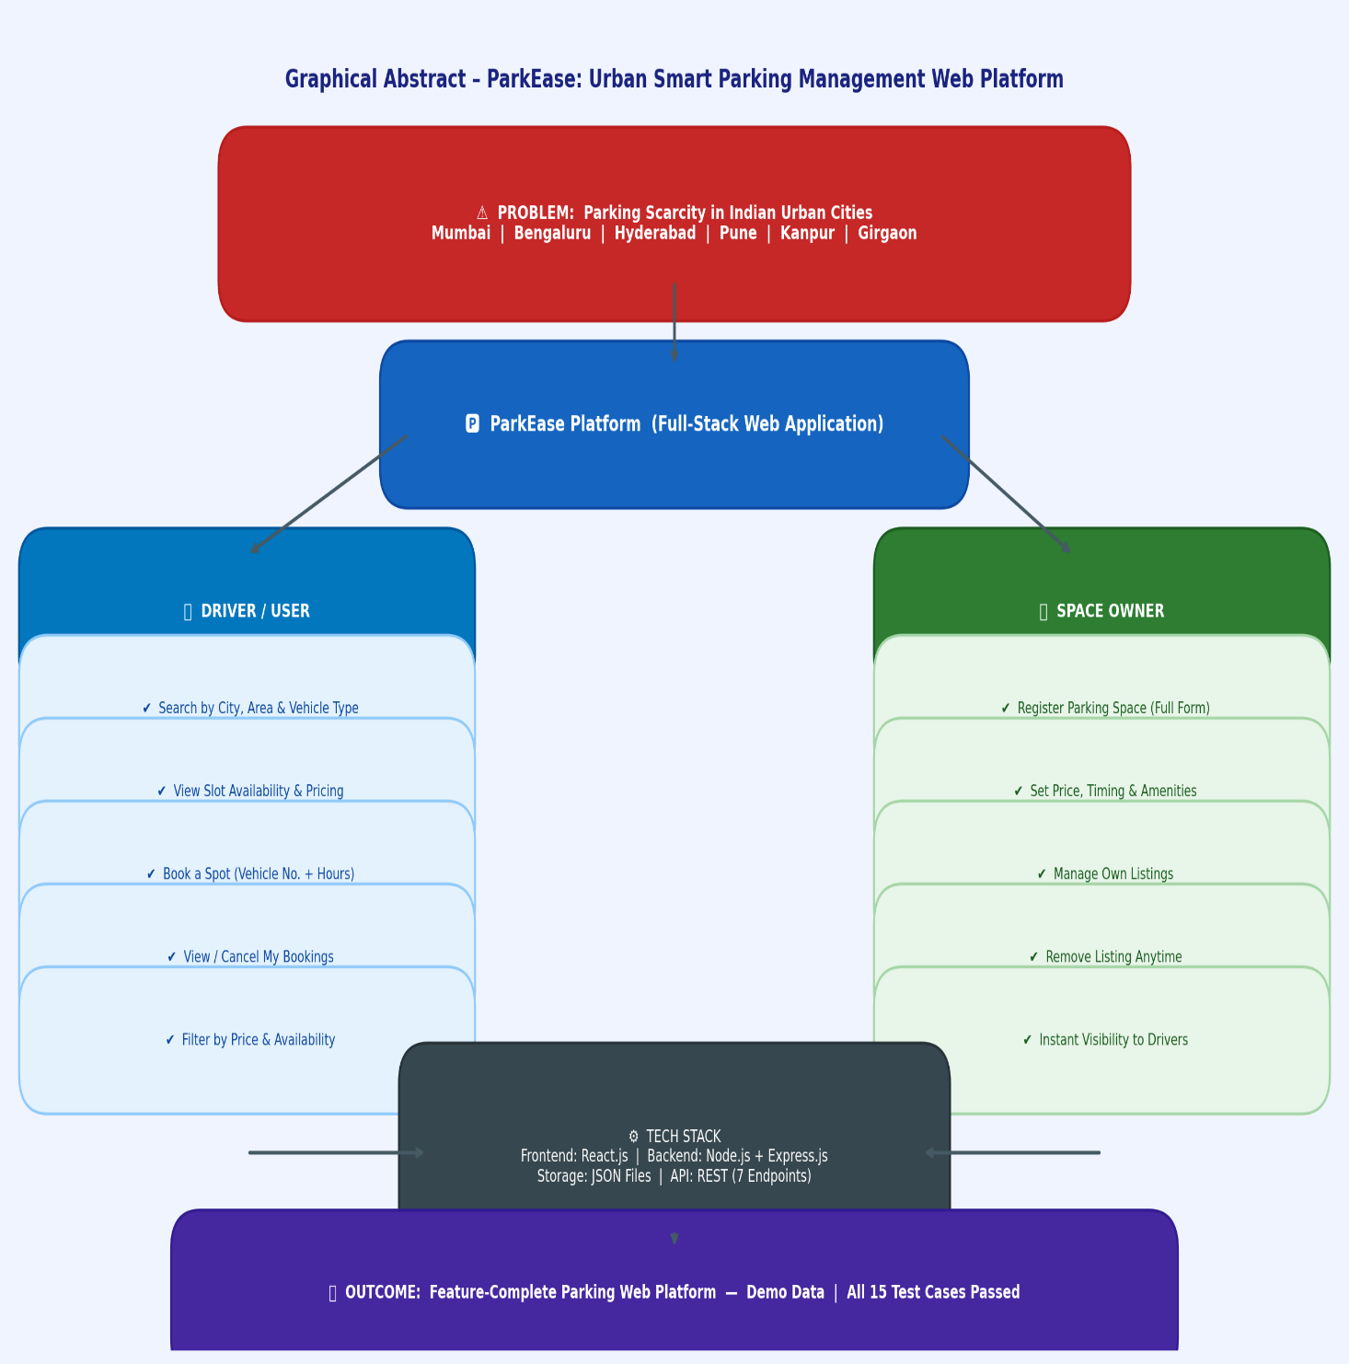

ABBREVIATIONS

Abbreviation | Full Form
API | Application Programming Interface
CORS | Cross-Origin Resource Sharing
CSS | Cascading Style Sheets
DOM | Document Object Model
ER | Entity Relationship
ES6 | ECMAScript 2015 (6th Edition)
EV | Electric Vehicle
CCTV | Closed-Circuit Television
GET | HTTP GET Method (Retrieve Resource)
HTTP | Hypertext Transfer Protocol
HTML | Hypertext Markup Language
IETF | Internet Engineering Task Force
JSON | JavaScript Object Notation
JSX | JavaScript XML
MVC | Model-View-Controller
npm | Node Package Manager
POST | HTTP POST Method (Create Resource)
DELETE | HTTP DELETE Method (Remove Resource)
REST | Representational State Transfer
RFC | Request for Comments
SPA | Single Page Application
UI | User Interface
UX | User Experience
URL | Uniform Resource Locator
W3C | World Wide Web Consortium

SYMBOLS

Symbol | Meaning
Rs. | Indian Rupee (currency for parking price per hour)
/ | Per (as in Rs./hr = Rupees per hour)
{} | JSON object / JavaScript object literal
[] | JSON array / JavaScript array
-> | Navigates to / leads to / HTTP response direction
<- | Returns from / sends back
* | Required field (in form context)
// | Single-line comment in JavaScript / Node.js code
>= | Greater than or equal to
<= | Less than or equal to

CHAPTER 1

INTRODUCTION
  - Identification of Client / Need / Relevant Contemporary Issue

India is undergoing one of the fastest urbanization phases in the world. As of 2024, over 500 million people reside in urban India, a figure projected to exceed 800 million by 2050 (United Nations, 2023). This urban migration has triggered an exponential rise in motor vehicle registrations. According to the Ministry of Road Transport and Highways (MoRTH), India's total registered vehicle population crossed 340 million in 2023, with cities like Mumbai, Bengaluru, and Hyderabad alone accounting for tens of millions of registered vehicles.
Vehicle density has significantly outpaced organized parking infrastructure. Mumbai faces a parking deficit of approximately 1.2 million spaces (BMC, 2022). Bengaluru's traffic police report that nearly 30% of urban traffic congestion is directly caused by on-street parking and vehicles circling in search of spaces. Similar conditions are observed in Hyderabad, Pune, Kanpur, and the densely populated Mumbai neighbourhood of Girgaon.
The problem is compounded by the rapid growth of cab aggregator platforms — Ola, Uber, and Rapido — whose millions of driver-partners operate continuously in dense urban areas and require dependable parking access during breaks, between rides, and at night. These drivers represent a large and underserved user segment.
India's Smart Cities Mission (2015), targeting 100 cities, has identified intelligent parking systems as a key smart mobility component. ParkEase aligns with this initiative by demonstrating how a web-based platform can serve as the digital foundation for a smart urban parking ecosystem.
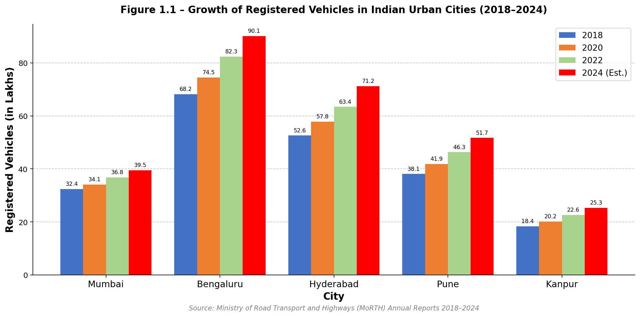
Figure 1.1 – Growth of Registered Vehicles in Indian Urban Cities (2018–2024)
Note: All vehicle registration figures are indicative values sourced from MoRTH annual reports and state transport department publications, used for contextual background only. All data within ParkEase itself is fabricated demo data.
  - Identification of Problem

The following six core problems were identified through background research and observation of parking conditions in Indian urban areas:
- i) Absence of a Centralized Parking Discovery Platform — Drivers have no single reliable platform to search for nearby available parking in Indian urban areas. Discovery happens through word-of-mouth or physical exploration, wasting time and fuel.
- ii) Underutilization of Private Parking Spaces — Large numbers of private spaces in residential complexes, commercial basements, and open plots remain empty during daytime, while drivers struggle to find parking nearby.
- iii) No Real-Time Availability Information — Even where dedicated parking lots exist, there is no mechanism to check slot availability before arriving, causing wasted trips and increased congestion.
- iv) No Digital Booking or Reservation System — Parking in Indian cities is overwhelmingly informal and cash-based with no pre-booking capability, preventing advance planning.
- v) Lack of Pricing and Amenity Information — Drivers have no advance knowledge of parking prices, vehicle type compatibility, available amenities (CCTV, guard, EV charging), or operating hours before reaching a location.
- vi) Fragmented Platform for Owners — Private space owners who wish to monetize unused parking areas have no structured platform to list, manage, and publicize their spaces.
  - Identification of Tasks

Based on the identified problems, the following tasks were undertaken:
- Task 1 – Requirements Analysis: Study the urban parking problem, identify user types (driver and owner), and define functional requirements.
- Task 2 – Literature Review: Survey existing parking solutions, academic papers, and full-stack web application design patterns.
- Task 3 – System Design: Design system architecture, JSON database schema, API endpoints, React component hierarchy, and interface wireframes.
- Task 4 – Frontend Development: Build React.js frontend with four pages (Home, Find Parking, List Space, My Bookings) and four reusable components (Navbar, ParkingCard, BookingModal, Toast).
- Task 5 – Backend Development: Build Node.js + Express.js backend with 7 RESTful API endpoints and JSON file-based data persistence.
- Task 6 – Integration and Testing: Connect frontend and backend, test all user flows (search, book, list, cancel), validate with demo data.
- Task 7 – Documentation: Prepare the complete project report, user manual, and design checklist.
  - Timeline

Task | Week 1 | Week 2 | Week 3 | Week 4 | Week 5 | Week 6 | Week 7 | Week 8
Requirements Analysis | ■ | ■
Literature Review |  | ■ | ■
System Design |  |  | ■ | ■
Frontend Development |  |  |  | ■ | ■ | ■
Backend Development |  |  |  |  | ■ | ■
Integration & Testing |  |  |  |  |  |  | ■ | ■
Documentation & Report |  |  |  |  |  |  |  | ■
Table 1.1 – Project Timeline – Gantt Chart
The project timeline is detailed in Table 1.1 above.
  - Organization of the Report

- Chapter 1 – Introduction: Identifies the urban parking problem, defines problem statements, lists tasks, and presents the project timeline.
- Chapter 2 – Literature Review: Reviews the historical evolution of the parking problem, surveys existing solutions and academic research, presents bibliometric analysis, and defines the project scope and goals.
- Chapter 3 – Design Flow / Process: Evaluates and selects platform features, analyzes design constraints, presents two alternative architectures, details the selected design, and explains implementation methodology with flowcharts and diagrams.
- Chapter 4 – Results Analysis and Validation: Presents the implemented solution with figure placeholders for screenshots, API endpoint documentation, demo data tables, and test case results.
- Chapter 5 – Conclusion and Future Work: Summarizes outcomes and presents a roadmap for extending ParkEase into a production-grade platform.
- References, Appendix, and User Manual follow Chapter 5.

CHAPTER 2

LITERATURE REVIEW/BACKGROUND STUDY

2.1 Timeline of the Reported Problem

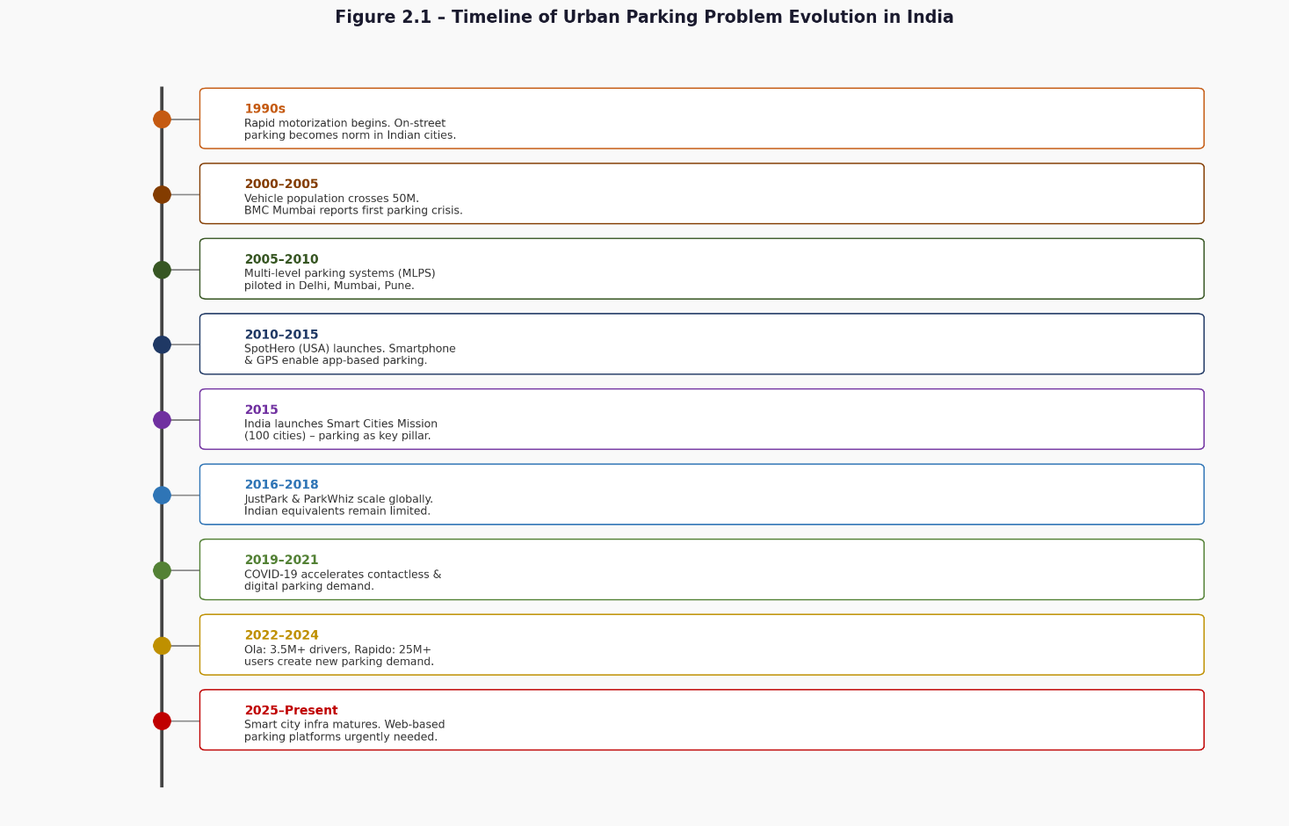
Figure 2.1 – Timeline of Urban Parking Problem Evolution in India
Period | Development
1990s | Rapid motorization begins. On-street parking becomes the norm.
2000–2005 | Vehicle population crosses 50 million. BMC Mumbai and BBMP Bengaluru publish first formal parking crisis documents.
2005–2010 | Multi-level automated parking systems piloted in Delhi, Mumbai, Pune. High cost limits adoption.
2010–2015 | Smartphone + GPS create conditions for app-based parking. International platforms like SpotHero (USA) launch.
2015 | India launches Smart Cities Mission targeting 100 cities. Intelligent parking identified as key mobility component.
2016–2018 | ParkWhiz, JustPark (UK) scale internationally. Indian equivalents remain limited and city-specific.
2019–2021 | COVID-19 disrupts mobility but accelerates digital parking demand.
2022–2024 | Cab aggregator growth (Ola: 3.5M+ drivers, Rapido: 25M+ users) creates large new parking demand segment.
2025–Present | Smart city digital infrastructure matures. Scalable web-based parking platforms urgently needed in Tier-2 and Tier-3 cities.

2.2 Existing Solutions

A comparative survey of existing parking management solutions was conducted to identify gaps that ParkEase addresses.
Solution | Type | Cities Covered | Key Features | Limitations
SpotHero (USA) | Web + Mobile | 300+ US cities | Real-time booking, pre-payment, GPS | Not available in India
JustPark (UK) | Web + Mobile | UK cities | Space listing by owners, hourly booking | Not available in India
ParkMate | Mobile App | Select Indian cities | QR-based entry, monthly subscriptions | Limited to tied-up operators only
Smart Parking (Govt.) | IoT Sensor | Select smart cities | Sensor data, digital signage | Expensive IoT infrastructure
WhatsApp/Informal | Informal | Local areas | Word-of-mouth, local contact | No standardization or booking
ParkEase (Proposed) | Web Platform | 6 Indian cities | Search, book, list, manage — all-in-one | Demo data; no real-time GPS currently
Table 2.1 – Comparison of Existing Parking Management Solutions
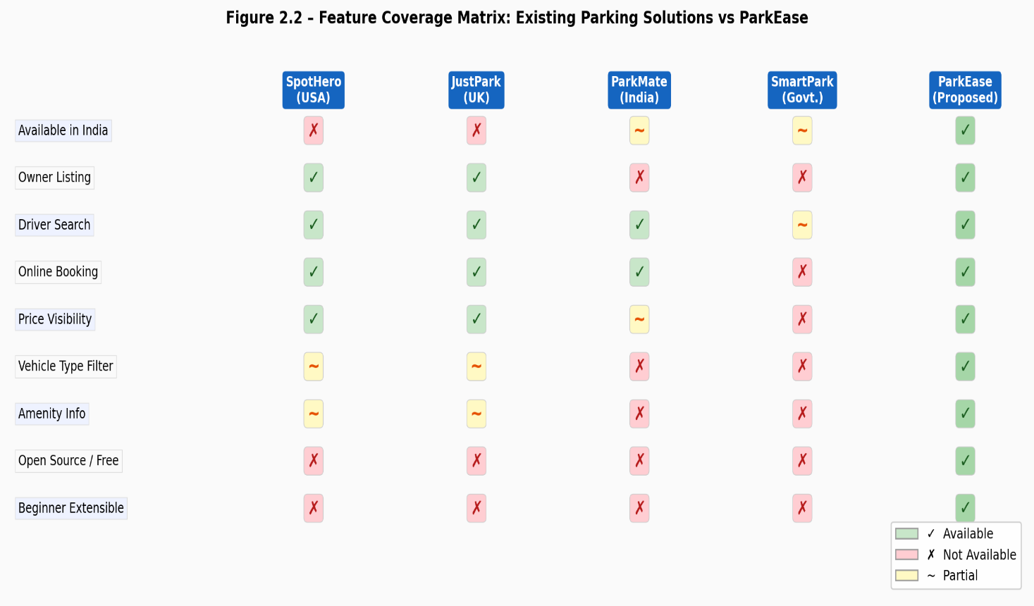
Figure 2.2 – Feature Coverage Matrix – Comparison of Existing Solutions
2.3 Bibliometric Analysis

A bibliometric analysis of research publications related to smart parking systems, urban parking management, and web-based mobility solutions was conducted using Google Scholar, IEEE Xplore, and ResearchGate. The analysis covered publications from 2015 to 2025.
Keyword | Frequency | Research Trend
Smart Parking System | High | Increasing (IoT-dominated)
Urban Parking Management | High | Steady
Real-Time Parking Availability | High | Increasing
Parking Reservation System | Medium | Increasing
Web-Based Parking Platform | Medium | Emerging
IoT Parking Sensor | High | Dominant 2018–2022
Mobile Application Parking | High | Stable
Parking Space Sharing Economy | Medium | Emerging post-2020
Full-Stack Web Application | Low | Emerging
RESTful API Parking | Low | Emerging
Table 2.2 – Bibliometric Summary – Top Research Keywords in Smart Parking
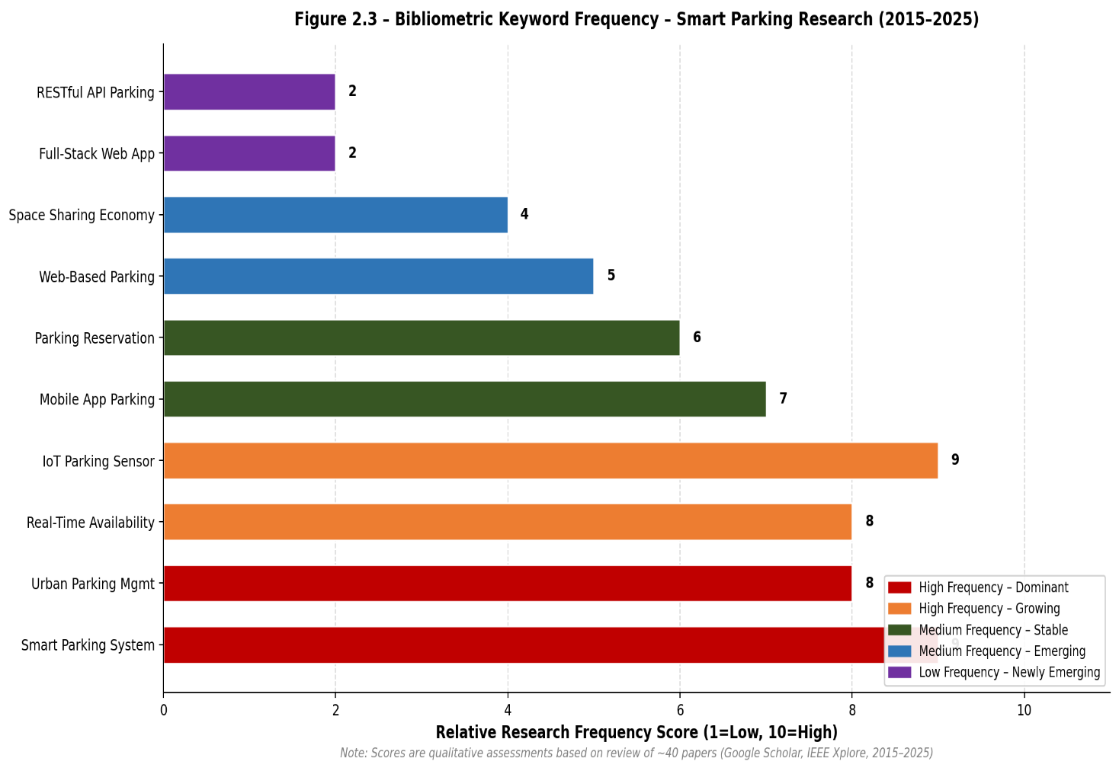
Figure 2.3 – Bibliometric Keyword Frequency Map – Smart Parking Research (2015–2025)
2.4 Review Summary
- IoT-heavy solutions require costly infrastructure, making them unsuitable for small-scale or Tier-2 city deployment.
- Web and app-based platforms exist internationally but remain very limited in India, especially outside Tier-1 cities.
- Sharing economy models (owner lists space, driver books space) prove effective and low-cost when implemented digitally.
- Full-stack web development using React.js and Node.js is well-established and scalable for parking platform development.
- Demo data-driven development is an accepted methodology for feature demonstration before real-user onboarding and database integration.
2.5 Problem Definition

Organized parking infrastructure in Indian cities has failed to keep pace with vehicle growth, causing severe parking scarcity in metropolitan areas. Thousands of private parking spaces remain unused while drivers waste time and fuel searching. No centralized, web-based platform exists for owners to list spaces and drivers to search and book parking. ParkEase bridges this gap with a full-stack web application demonstrating end-to-end parking discovery, booking, listing, and management — using demo data to prove all features function correctly before real deployment.
2.6 Goals / Objectives

- Design and implement a full-stack web application using React.js frontend and Node.js + Express.js backend.
- Enable parking discovery filtered by city, area keyword, and vehicle type, showing real-time slot availability.
- Enable booking with vehicle number and duration input via a modal interface.
- Enable space registration through a detailed multi-field form.
- Provide booking and listing management pages for both user types.
- Implement a RESTful API with 7 endpoints covering complete CRUD-like operations.
- Pre-populate 18 synthetic demo parking records across 6 Indian cities for feature demonstration.

CHAPTER 3

DESIGN FLOW/PROCESS

3.1 Evaluation & Selection of Specifications / Features

Feature ID | Feature Description | User Role | Priority | Feasibility | Selected
F-01 | Search parking by city and vehicle type | Driver | High | High | Yes
F-02 | Search by area keyword / landmark | Driver | High | High | Yes
F-03 | View slot availability (real-time via API) | Driver | High | High | Yes
F-04 | View price per hour for each spot | Driver | High | High | Yes
F-05 | View amenity details (CCTV, EV, Guard, Wash) | Driver | Medium | High | Yes
F-06 | Book a parking spot with vehicle no. and hours | Driver | High | High | Yes
F-07 | View and cancel own bookings | Driver | High | High | Yes
F-08 | Register / list own parking space | Owner | High | High | Yes
F-09 | Remove own parking listing | Owner | Medium | High | Yes
F-10 | Real-time GPS map integration | Driver | High | Low | No
F-11 | Payment gateway integration | Driver | High | Low | No
F-12 | User registration and login (Authentication) | Both | High | Medium | No
F-13 | Rating and review system | Driver | Medium | Medium | No
F-14 | Owner earnings dashboard | Owner | Medium | Medium | No
F-15 | Price range filter | Driver | Medium | High | Yes
F-16 | Availability status filter | Driver | Medium | High | Yes
Table 3.1 – Feature Evaluation Matrix – Required vs. Selected Features
3.2 Design Constraints

Constraint Category | Description | Impact on Design
Standards | REST, HTTP/1.1, JSON standards must be followed. | API uses GET, POST, DELETE with JSON request/response bodies.
Economic | Free and open-source tools only. No paid APIs or cloud DBs. | Tech stack limited to React.js, Node.js, Express.js; JSON file storage.
Technical/Skill | Beginner-level full-stack development (2–3 months experience). | No TypeScript, Redux, MongoDB, or auth middleware. Plain CSS only.
Storage | Use JSON file storage on local filesystem. | No external database server required.
Professional/Ethical | All data must be synthetic. No real user or financial data. | 18 pre-populated fabricated spot records only.
Social | Accessible to general users; simple interface required. | Clear labels, standard HTML forms, no complex interactions.
Safety | No user authentication; no sensitive data stored. | Phone numbers fabricated; no passwords or real emails.
Environmental | Runs locally; no cloud deployment in current version. | Minimal environmental footprint.
Table 3.2 – Design Constraints Analysis
3.3 Analysis of Features and Finalization Subject to Constraints

Feature | Original Specification | Constraint Applied | Final Implementation
Search location | GPS-based "near me" search | Technical (complex) | Replaced with city + keyword text search
Payment on booking | Online payment gateway | Economic + Technical | Demo booking confirmation only (no real payment)
User login/signup | Email + password auth | Technical constraint | Removed; all features accessible without login
Real database | MongoDB or MySQL | Economic + Technical | JSON file storage via Node.js fs module
Rating system | 1–5 star rating per spot | Technical constraint | Removed; deferred to future work
Filter by price | Slider-based price filter | HTML constraint | Implemented as chip-button price range filter
Slot availability | Real-time IoT sensor data | Technical + Economic | Demo data with API-driven slot count reduction on booking
Table 3.3 – Feature Finalization Table – After Constraint Analysis
3.4 Design Flow

This section presents two alternative design approaches evaluated during system architecture planning, followed by the selected approach.
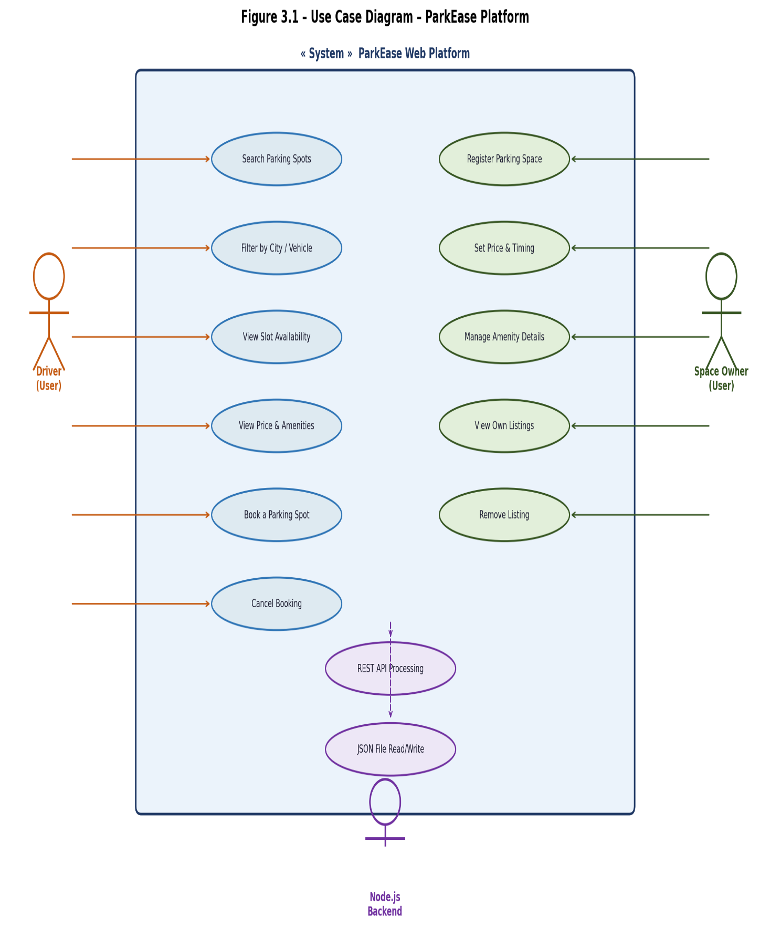
Figure 3.1 – Use Case Diagram – ParkEase Platform
Alternative Design A — Single-Page Application (SPA) Architecture:
In this approach, the entire application runs as a React SPA with client-side routing. All pages are loaded once and switching between views happens without server round-trips. Data is fetched via API calls.
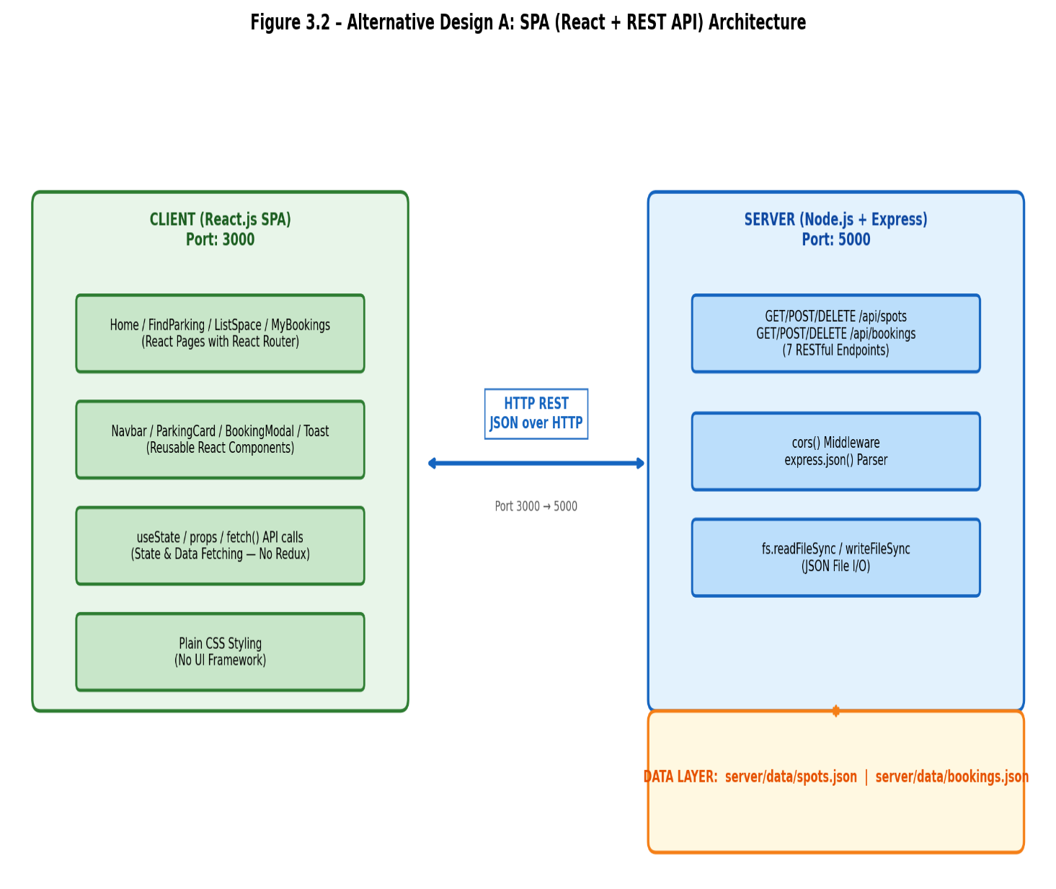
Figure 3.2 – Alternative Design A – Single-Page Application Architecture
Alternative Design B — Multi-Page Server-Side Rendering Architecture:
In this approach, Node.js renders each page on the server and sends complete HTML to the browser. Every page navigation causes a full server request.
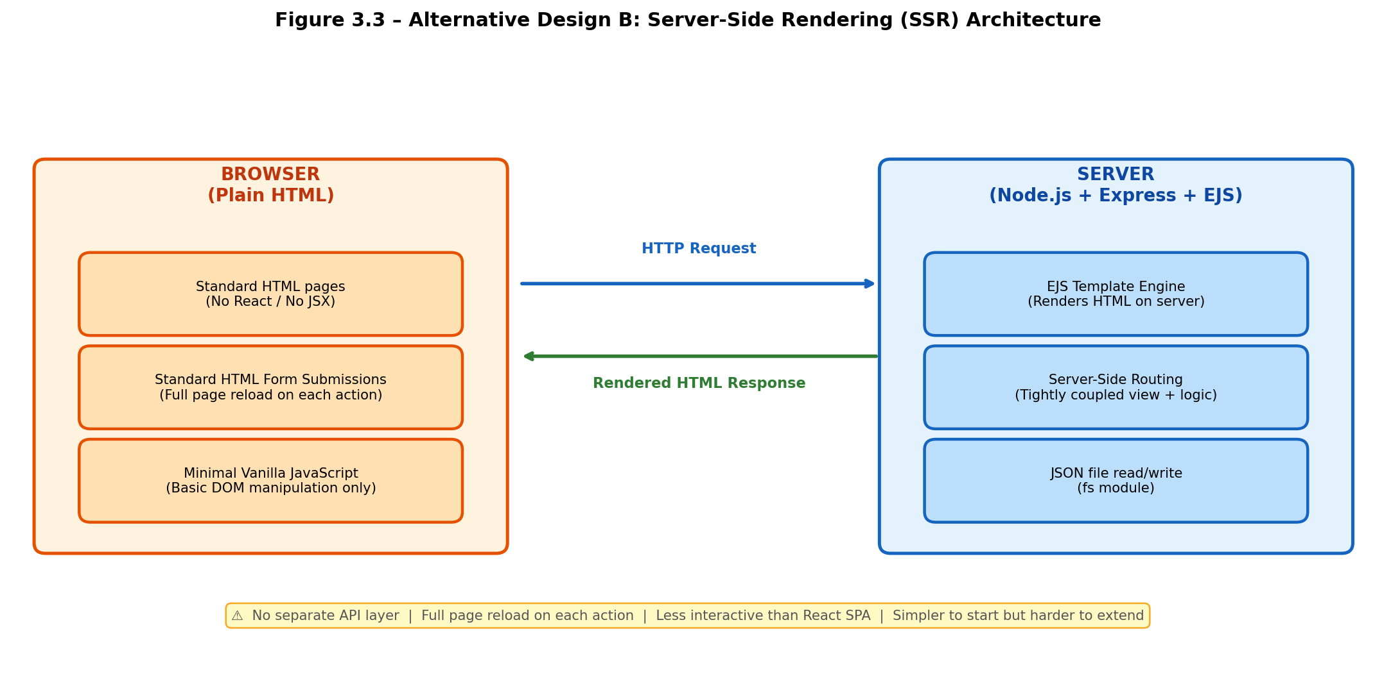
Figure 3.3 – Alternative Design B – Multi-Page Server-Side Rendering Architecture

User Booking Flow:
The following textual flowchart describes the complete driver booking process:
START
→ Open ParkEase App (http://localhost:3000)
→ Navigate to "Find Parking"
→ Select City + Vehicle Type + Enter Keyword (optional)
→ Click "Search" Button
→ React calls GET /api/spots?city=...&vehicle=...
→ Server reads spots.json, filters records, returns JSON array
→ React renders ParkingCard components
→ User selects a card where availableSlots > 0
→ Click "Book Now"
→ BookingModal opens (enter vehicle number + hours)
→ Click "Confirm Booking"
→ React calls POST /api/bookings with { spotId, vehicleNumber, hours }
→ Server: (1) Creates booking record (2) Reduces spot.availableSlots by 1 (3) Saves both JSON files (4) Returns new booking object
→ React shows Toast: "Booking Confirmed!"
END
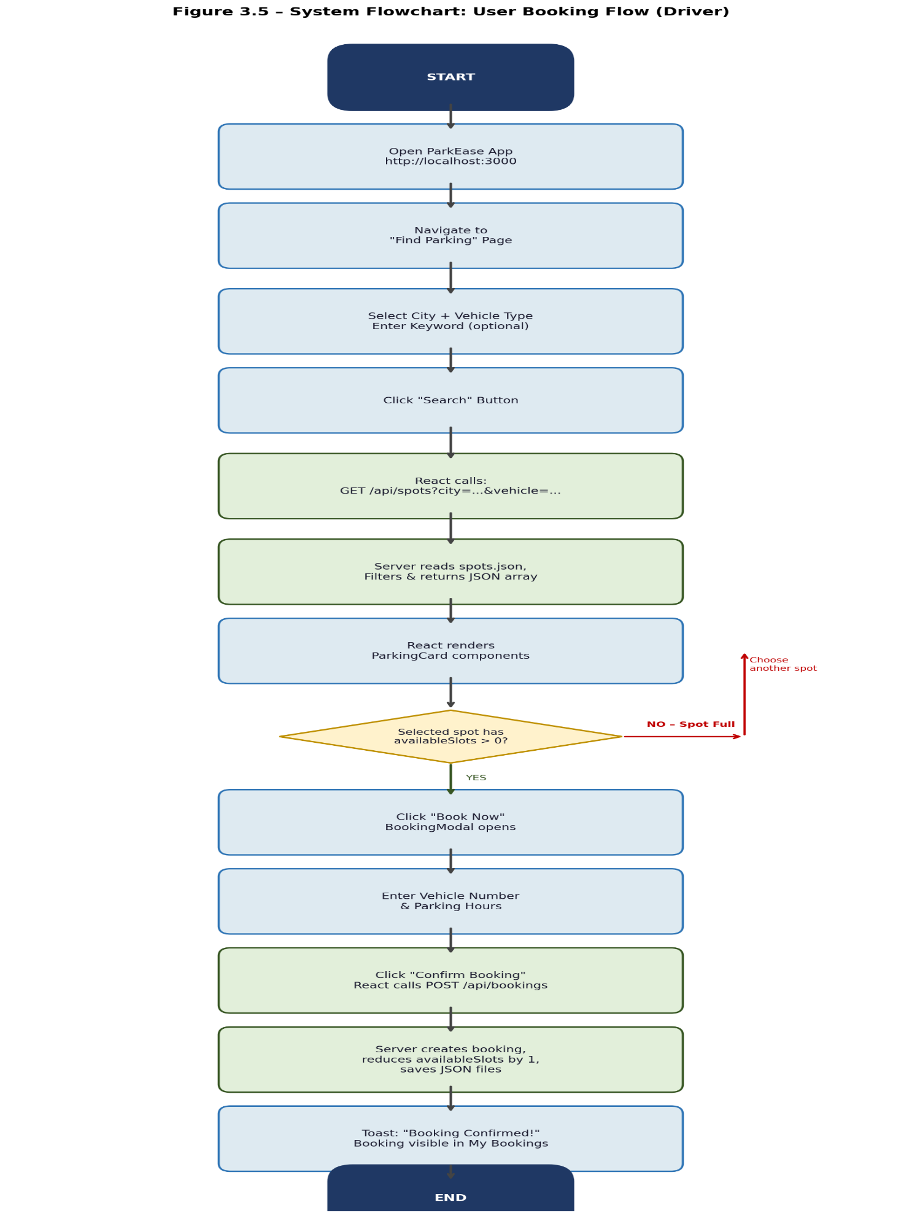
Figure 3.5 – System Flowchart – User Booking Flow (Driver)
Owner Listing Flow:
START
→ Navigate to "List Space"
→ Fill Registration Form: Name, City, Area, Address, Vehicle Type, Total Slots, Price/hr, Parking Type, Open Time, Close Time, Amenities, Owner Phone
→ Check: All required fields filled?
→ NO: Show inline validation errors and stop
→ YES: Submit form
→ React calls POST /api/spots with complete form data
→ Server appends new spot record to spots.json with auto-generated ID
→ React shows Toast: "Space Listed Successfully!"
→ New spot is immediately searchable by all drivers
END
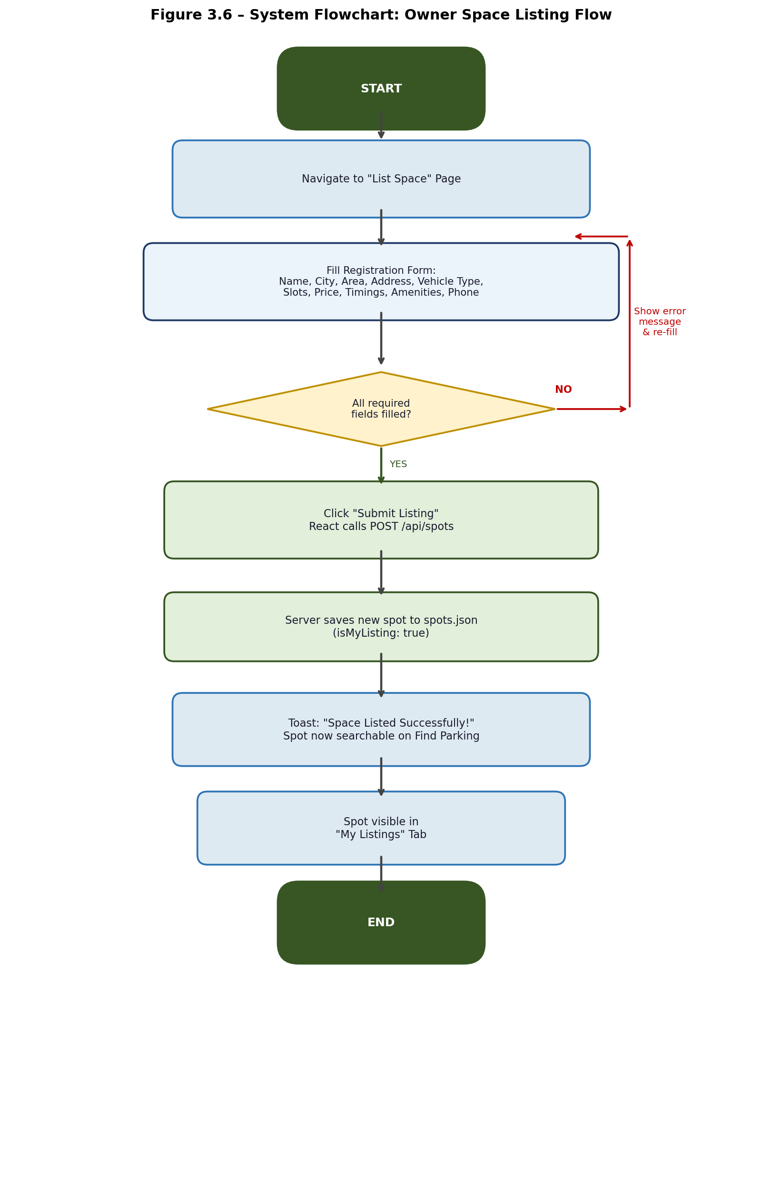
Figure 3.6 – System Flowchart – Owner Listing Flow

3.5 Design Selection

Architecture | Description | Pros | Cons
SPA (Alternative A) | React frontend, client-side routing only, REST API backend | Fast UI, smooth navigation, component reuse, API separation | Requires API design, initial load time, SEO limitations
Multi-Page SSR (Alternative B) | Node.js renders full HTML pages, templates on server | SEO friendly, simpler mental model, less JavaScript | Slower UI, full page reload on navigation, more server load
Selected: React + Node.js | Decoupled: React SPA frontend + Express REST API backend | Best balance of performance, modularity, beginner-learnability | Requires CORS configuration and proxy setup
Table 3.4 – Comparison of Alternative Architectures
Selected Design Rationale:
The decoupled React + Node.js architecture was selected because it separates concerns clearly (frontend handles UI, backend handles data), is the industry-standard approach for modern web applications, and provides the best learning opportunity for a beginner full-stack student. The React frontend communicates with the Node.js backend exclusively through a well-defined REST API.

3.6 Implementation Plan / Methodology

Project Folder Structure:
parkease/
├── client/ ← React Application
│ ├── public/
│ │ └── index.html
│ ├── src/
│ │ ├── components/
│ │ │ ├── Navbar.js ← Navigation bar with 4 links
│ │ │ ├── ParkingCard.js ← Individual parking spot card
│ │ │ ├── BookingModal.js← Booking confirmation modal
│ │ │ └── Toast.js ← Success/error notification
│ │ ├── pages/
│ │ │ ├── Home.js ← Landing page
│ │ │ ├── FindParking.js ← Search + filter + results
│ │ │ ├── ListSpace.js ← Owner registration form
│ │ │ └── MyBookings.js ← Booking & listing management
│ │ ├── App.js ← Router and layout
│ │ └── index.js ← React entry point
│ └── package.json
└── server/ ← Node.js / Express API
├── data/
│ ├── spots.json ← 18 demo parking spots
│ └── bookings.json ← Booking records (starts empty)
├── routes/
│ ├── spots.js ← GET /api/spots, POST /api/spots, DELETE /api/spots/:id
│ └── bookings.js ← GET /api/bookings, POST /api/bookings, DELETE /api/bookings/:id
├── server.js ← Express server entry point
└── package.json
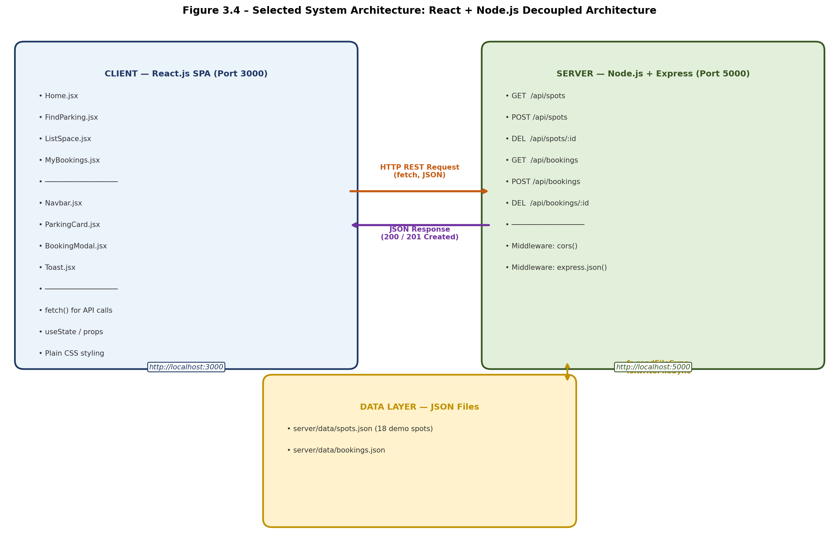
Figure 3.4 – Selected System Architecture – React + Node.js Decoupled Architecture
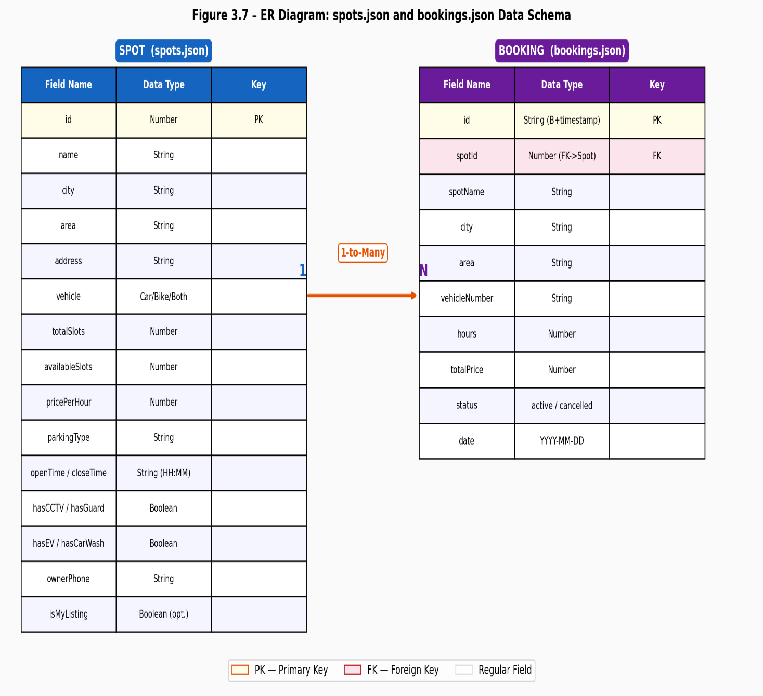
Figure 3.7 – Entity Relationship (ER) Diagram – spots.json and bookings.json
API Endpoints (7 total):
GET /api/spots – Retrieve all spots (supports ?city= ?vehicle= filters)
GET /api/spots/:id – Retrieve single spot by ID
POST /api/spots – Add new parking spot (owner listing)
DELETE /api/spots/:id – Remove a parking spot listing
GET /api/bookings – Retrieve all bookings
POST /api/bookings – Create a new booking (decrements availableSlots)
DELETE /api/bookings/:id – Cancel a booking

CHAPTER 4

RESULTS ANALYSIS AND VALIDATION

4.1 Implementation of Solution

The ParkEase platform was implemented as described in Chapter 3. All 11 selected features (F-01 through F-09, F-15, F-16) were successfully implemented and validated using 18 pre-populated demo parking records across 6 Indian cities. All data is completely fabricated for demonstration purposes.
ID | Name | City | Area | Vehicle | Total Slots | Available Slots | Price/hr (Rs.) | Parking Type | CCTV | Guard | EV
1 | Andheri Station Parking | Mumbai | Andheri West | Both | 40 | 12 | 40 | Covered | Yes | Yes | No
2 | Bandra Kurla Complex Lot | Mumbai | BKC | Car | 80 | 5 | 70 | Multi-level | Yes | Yes | Yes
3 | Koramangala Parking Zone | Bengaluru | Koramangala | Both | 60 | 28 | 50 | Open | Yes | No | No
4 | HITEC City Tech Park Lot | Hyderabad | HITEC City | Car | 100 | 0 | 60 | Covered | Yes | Yes | Yes
5 | Shivajinagar Bus Stand Area | Pune | Shivajinagar | Both | 35 | 18 | 30 | Open | No | No | No
Table 4.1 – Demo Parking Spots Data (Sample – 5 of 18 Records)
Note: All above data is completely fabricated demo data for feature demonstration only.
Home_Page:
The Home page serves as the landing page displaying the ParkEase platform name, a brief description of the service, and navigation to the key features. It displays aggregate statistics (total spots, cities covered, available slots) derived from the demo data via API call on page load.
[ Screenshot to be inserted here ]
Figure 4.1 – Screenshot: Home Page of ParkEase [PLACEHOLDER]

Find_Parking_Page:
The Find Parking page provides the primary driver-facing interface. It contains a search bar with city dropdown, vehicle type selector (Car / Bike / Both), keyword text input for area search, price range filter buttons, and availability toggle. Search results are displayed as ParkingCard components in a grid layout.
[ Screenshot to be inserted here ]
Figure 4.2 – Screenshot: Find Parking Page with Search Filters [PLACEHOLDER]
[ Screenshot to be inserted here ]
Figure 4.3 – Screenshot: Parking Spot Card with Book Now Button [PLACEHOLDER]
Booking_Confirmation_Modal:
When a driver clicks "Book Now" on any card with available slots, a BookingModal overlay appears. The modal displays spot name, location, price per hour, available slots count, parking type, and amenities. The driver enters their vehicle number and desired hours, then clicks "Confirm Booking" to submit via POST /api/bookings.
[ Screenshot to be inserted here ]
Figure 4.4 – Screenshot: Booking Confirmation Modal [PLACEHOLDER]
Endpoint | Method | Description | Request Body | Response
/api/spots | GET | Get all spots; supports ?city= ?vehicle= query params | None | JSON array of spot objects
/api/spots/:id | GET | Get single spot by numeric ID | None | JSON spot object
/api/spots | POST | Add new parking spot (owner listing) | Spot JSON | New spot object with generated ID
/api/spots/:id | DELETE | Remove a spot listing permanently | None | Success message
/api/bookings | GET | Get all current bookings | None | JSON array of booking objects
/api/bookings | POST | Create booking; decrements availableSlots by 1 | Booking JSON | New booking object
/api/bookings/:id | DELETE | Cancel a booking | None | Success message
Table 4.2 – API Endpoints Summary – ParkEase Backend
List_Your_Space_Page:
The List Your Space page contains a structured registration form with the following fields: Parking Name, City (dropdown), Area, Full Address, Vehicle Type Accepted, Total Parking Slots, Price per Hour (Rs.), Parking Type (Open/Covered/Multi-level), Opening Time, Closing Time, Amenity Checkboxes (CCTV/Guard/EV Charging/Car Wash), and Owner Contact Phone. On valid form submission, POST /api/spots is called and the new spot appears immediately in the Find Parking results.
[ Screenshot to be inserted here ]
Figure 4.5 – Screenshot: List Your Space Registration Form [PLACEHOLDER]
My_Bookings_Page:
The My Bookings page has two tabs — "My Bookings" and "My Listings". The Bookings tab displays all bookings made during the current session with spot name, location, vehicle number, hours booked, and a "Cancel Booking" button. The Listings tab shows all spots registered by the owner during the session with a "Remove Listing" button.
[ Screenshot to be inserted here ]
Figure 4.6 – Screenshot: My Bookings Page – Bookings Tab [PLACEHOLDER]
[ Screenshot to be inserted here ]
Figure 4.7 – Screenshot: My Bookings Page – Listings Tab [PLACEHOLDER]
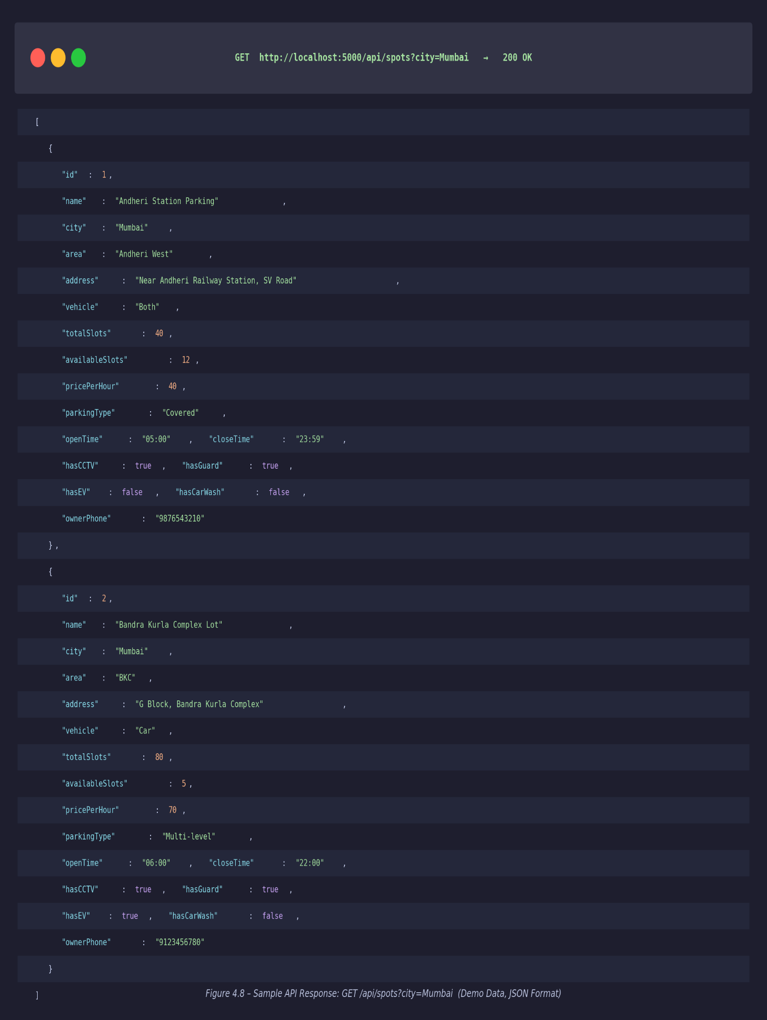
Figure 4.8 – API Response: GET /api/spots?city=Mumbai (Demo JSON)
TC No. | Test Case Description | Input | Expected Output | Actual Output | Status
TC-01 | Search spots by city "Mumbai" | city=Mumbai | Cards for Mumbai spots only | Correct results displayed | PASS
TC-02 | Search by vehicle type "Bike" | vehicle=Bike | Cards for Bike/Both spots only | Correct results displayed | PASS
TC-03 | Search by area keyword "Andheri" | keyword=Andheri | Andheri Station Parking card shown | Correct card displayed | PASS
TC-04 | Book Now on available spot | validSpotId, vehicle no | Booking created, slots decremented | Booking confirmed, Toast shown | PASS
TC-05 | Book Now on fully occupied spot (slots=0) | spotId with 0 slots | "Book Now" button disabled | Button correctly disabled | PASS
TC-06 | Register new parking space via form | Complete form data | New spot in Find Parking results | Spot appears immediately | PASS
TC-07 | Submit form with missing required fields | Incomplete form | Error shown, form not submitted | Validation errors displayed | PASS
TC-08 | Cancel a booking from My Bookings tab | Existing booking ID | Booking removed from list | Booking removed, Toast shown | PASS
TC-09 | Remove a listing from My Listings tab | Existing spot ID | Spot removed from Find Parking | Spot removed immediately | PASS
TC-10 | Filter by price range "Under Rs. 50" | priceFilter=50 | Only spots with price <= 50 shown | Correct filtering applied | PASS
TC-11 | Filter by availability (available only) | available=true | Only spots with slots > 0 shown | Correct filtering applied | PASS
TC-12 | GET /api/spots API endpoint | GET request | JSON array of 18 spot objects | 200 OK with correct JSON | PASS
TC-13 | POST /api/bookings API endpoint | Valid booking JSON body | 201 Created with booking object | Correct response returned | PASS
TC-14 | DELETE /api/bookings/:id endpoint | Valid booking ID | 200 OK with success message | Booking deleted successfully | PASS
TC-15 | Navigate between all 4 pages | Click nav links | Pages render without errors | All pages render correctly | PASS
Table 4.3 – Test Cases and Results

CONCLUSION AND FUTURE WORK

5.1 Conclusion

ParkEase was developed as a feature-focused, full-stack web application to address the acute urban parking scarcity problem in Indian metropolitan cities including Mumbai, Bengaluru, Hyderabad, Pune, Kanpur, and Girgaon. The platform successfully demonstrates a complete end-to-end urban parking management ecosystem comprising parking discovery, slot availability viewing, digital booking, space registration, and booking/listing management — all within a single web-based platform.
The project achieved all stated objectives. Eleven features were successfully implemented and validated through 15 test cases, all of which passed. A RESTful API with seven endpoints was developed and tested. The React.js frontend communicates seamlessly with the Node.js + Express.js backend. Eighteen fabricated demo parking records across six cities demonstrate all platform features without using any real user or parking data.
The platform deviated from the original specification in three areas: GPS-based location search was replaced with city + keyword text search (due to technical complexity at beginner level); payment gateway integration was deferred to future work; and user authentication was removed to keep the architecture simple. These deviations were expected, documented as design constraints, and do not affect the demonstration of core parking management features.
ParkEase demonstrates that a functional urban parking management platform can be built using beginner-level full-stack skills (React.js + Node.js) without expensive IoT hardware or complex infrastructure, making it viable for small-scale deployment in Indian cities.
5.2 Future Work

Phase | Enhancement | Technology | Priority
Phase 1 (3–6 months) | Replace JSON storage with MongoDB database | MongoDB, Mongoose ODM | High
Phase 1 | Add user authentication (registration + login) | JWT tokens, bcrypt | High
Phase 2 (6–12 months) | Real-time GPS map integration for "near me" search | Google Maps API / Leaflet.js | High
Phase 2 | Payment gateway integration for digital transactions | Razorpay / Stripe API | High
Phase 2 | Rating and review system for parking spots | MongoDB aggregation | Medium
Phase 3 (12+ months) | Mobile application development | React Native | Medium
Phase 3 | Owner earnings dashboard with analytics | Chart.js, MongoDB aggregation | Medium
Phase 3 | IoT sensor integration for real-time slot detection | MQTT, Arduino/ESP32 | Low
Phase 3 | Multi-language support (Hindi, regional languages) | i18next library | Low
Table 5.1 – Future Enhancement Roadmap
Future_Directions:
The most impactful near-term enhancement is replacing JSON file storage with MongoDB to enable concurrent multi-user access and persistent data across server restarts. Following this, adding JWT-based user authentication would enable personalized booking history, owner dashboards, and secure API access. In the medium term, real-time GPS integration and payment gateway support would transform ParkEase from a prototype into a production-ready platform. The long-term vision is a mobile application with IoT sensor support capable of operating at scale across all 100 Smart Cities Mission cities.

[1] Ministry of Road Transport and Highways (MoRTH), "Road Transport Yearbook 2022–23," Government of India, New Delhi, 2023. [Online]. Available: https://morth.nic.in
[2] Brihanmumbai Municipal Corporation (BMC), "Mumbai Parking Policy Report 2022," BMC Transport Department, Mumbai, 2022.
[3] S. Ahuja, P. Singh, and R. Sharma, "Smart Parking System Using IoT and Mobile Application," International Journal of Computer Applications, vol. 182, no. 14, pp. 1–6, Jan. 2019.
[4] R. Fielding and R. Taylor, "Principled Design of the Modern Web Architecture," ACM Transactions on Internet Technology, vol. 2, no. 2, pp. 115–150, May 2002.
[5] T. Ietf, "RFC 7231: Hypertext Transfer Protocol (HTTP/1.1): Semantics and Content," Internet Engineering Task Force, Jun. 2014. [Online]. Available: https://tools.ietf.org/html/rfc7231
[6] T. Bray, "RFC 8259: The JavaScript Object Notation (JSON) Data Interchange Format," Internet Engineering Task Force, Dec. 2017. [Online]. Available: https://tools.ietf.org/html/rfc8259
[7] W3C, "Cross-Origin Resource Sharing (CORS) Recommendation," World Wide Web Consortium, Jan. 2014. [Online]. Available: https://www.w3.org/TR/cors/
[8] ECMA International, "ECMAScript 2022 Language Specification (ECMA-262, 13th ed.)," ECMA International, Jun. 2022. [Online]. Available: https://www.ecma-international.org
[9] Z. Li and M. van Zuylen, "Parking Guidance Information Systems: Literature Review and Directions," Procedia — Social and Behavioral Sciences, vol. 96, pp. 2361–2372, Nov. 2013.
[10] A. Khanna and R. Anand, "IoT Based Smart Parking System," in Proc. International Conference on Internet of Things and Applications (IOTA), Pune, India, 2016, pp. 266–270. doi: 10.1109/IOTA.2016.7562735
[11] S. Nawaz, C. Efstratiou, and C. Mascolo, "ParkSense: A Smartphone Based Sensing System for On-Street Parking," in Proc. ACM MobiCom, Miami, FL, USA, 2013, pp. 75–86. doi: 10.1145/2500423.2500438
[12] Ministry of Housing and Urban Affairs, "Smart Cities Mission: Annual Report 2023," Government of India, New Delhi, 2023. [Online]. Available: https://smartcities.gov.in
[13] F. Bock, S. Di Martino, and A. Origlia, "Smart Parking: Using a Crowd of Taxis to Sense On-Street Parking Space Availability," IEEE Transactions on Intelligent Transportation Systems, vol. 21, no. 2, pp. 496–508, Feb. 2020. doi: 10.1109/TITS.2019.2899149
[14] A. Geng and A. Cassandras, "New 'Smart Parking' System Based on Resource Allocation and Reservations," IEEE Transactions on Intelligent Transportation Systems, vol. 14, no. 3, pp. 1129–1139, Sep. 2013. doi: 10.1109/TITS.2013.2252428
[15] SpotHero, "SpotHero Platform Overview," SpotHero Inc., Chicago, IL, USA. [Online]. Available: https://spothero.com. [Accessed: Apr. 2026]
[16] JustPark, "JustPark — UK Parking Platform," JustPark Ltd., London, UK. [Online]. Available: https://www.justpark.com. [Accessed: Apr. 2026]
[17] Meta Open Source, "React – A JavaScript Library for Building User Interfaces," Meta Platforms Inc., 2023. [Online]. Available: https://react.dev
[18] Node.js Foundation, "Node.js Documentation v20 LTS," OpenJS Foundation, 2024. [Online]. Available: https://nodejs.org/docs

A.1 Plagiarism Report

Plagiarism report to be attached here. The report was scanned using DupliChecker. Similarity Index: __%. Attached result screemshort below.
[ Plagiarism Report Certificate — to be inserted ]

A.2 Design Checklist

Item | Requirement | Status
F-01 | Parking search by city and vehicle type implemented | Complete
F-02 | Keyword area search implemented | Complete
F-03 | Real-time slot availability via API | Complete
F-04 | Price per hour display | Complete
F-05 | Amenity tags displayed (CCTV, Guard, EV, Wash) | Complete
F-06 | Booking modal with vehicle number and hours | Complete
F-07 | My Bookings page with cancel option | Complete
F-08 | Owner registration form with all fields | Complete
F-09 | Remove listing from My Listings tab | Complete
F-15 | Price range filter buttons | Complete
F-16 | Availability filter toggle | Complete
API | 7 RESTful endpoints implemented and tested | Complete
DATA | 18 demo parking records pre-populated | Complete
TEST | 15 test cases passed | Complete
DOCS | Project report completed | Complete
STD | REST, HTTP/1.1, JSON, CORS, ES6 standards followed | Complete

Step-by-Step Instructions to Set Up and Run ParkEase
- System Requirements

- Node.js v18 or later (download from https://nodejs.org)
- npm v9 or later (included with Node.js)
- Any modern web browser (Chrome, Firefox, Edge)
- 512 MB free RAM minimum
- 200 MB free disk space
- Installation Steps

Step 1 – Clone or Download the Project
Download the project folder named "parkease/" and extract it.
The folder contains two subfolders: client/ and server/
Step 2 – Install Backend Dependencies
Open a terminal window.
Type: cd parkease/server
Type: npm install
Wait for all packages to install (express, cors, nodemon).
Step 3 – Start the Backend Server
While still in the server/ folder, type: npm start
You should see the message: "ParkEase server running on port 5000"
Leave this terminal window open.
Step 4 – Install Frontend Dependencies
Open a second terminal window.
Type: cd parkease/client
Type: npm install
Wait for all React packages to install.
Step 5 – Start the Frontend Application
While still in the client/ folder, type: npm start
The React app will compile and open automatically in your browser at:
http://localhost:3000

- How to Use ParkEase

Feature 1 – Find Parking:
1. Click "Find Parking" in the navigation bar.
2. Select your city from the dropdown (Mumbai, Pune, Bengaluru, etc.).
3. Select your vehicle type (Car / Bike / Both).
4. Optionally type an area name in the search box.
5. Click "Search". Parking cards will appear below.
6. Use the price filter buttons to narrow results.
7. Toggle "Available Only" to hide fully occupied spots.
Feature 2 – Book a Parking Spot:
1. Find a spot with available slots (green badge).
2. Click the "Book Now" button on the card.
3. In the modal, enter your Vehicle Number (e.g., MH12AB1234).
4. Enter the number of hours you need parking.
5. Click "Confirm Booking".
6. A green toast notification confirms your booking.
7. The available slots count on the card will decrease by 1.
Feature 3 – List Your Parking Space (For Owners):
1. Click "List Space" in the navigation bar.
2. Fill in all required fields (marked with *):
- Parking Name, City, Area, Full Address
- Vehicle Types Accepted, Total Slots, Price per Hour
- Parking Type, Opening Time, Closing Time
- Check applicable amenities (CCTV, Guard, EV Charging, Car Wash)
- Your contact phone number
3. Click "List My Space".
4. A toast notification confirms successful listing.
5. Your space immediately appears in the Find Parking results.
Feature 4 – View and Manage Bookings:
1. Click "My Bookings" in the navigation bar.
2. The "My Bookings" tab shows all your bookings this session.
3. Click "Cancel Booking" next to any booking to cancel it.
4. Switch to the "My Listings" tab to see spots you have listed.
5. Click "Remove Listing" to take down a spot.
- Troubleshooting

- - "Cannot connect to server" error: Ensure the backend (npm start in server/) is running and shows "server running on port 5000".
- - Page shows blank / no results: Refresh the browser at http://localhost:3000
- - Port already in use: Kill the previous process using that port and restart.
- - npm install fails: Ensure Node.js v18+ is installed. Run: node --version

